MATH 45 REVIEW EXAM FINAL SPRING 2021

Q1. Find the critical points , phase portrait of the given autonomous first order differential equation . Classify each critical point as asymptotically stable , unstable or semi stable . By hand sketch the typical solution curves in the region in the x y plane determined by the graphs of the equilibrium solutions :

Y’ = y ( y – 1 ) ( y – 3 )

Q2. Solve the linear differential equation and find if there are any transient terms in general solution :

a) dy / dx – 3y = 6 Ans : y = -2 + c 𝑒 3𝑥 ,

b) x y’ + y = 𝑒 𝑥 , y(1) = 2 Ans : y = 1 𝑒𝑥 + 2−𝑒

c) ( x+1) dy/dx + ( x + 2) y = 2x 𝑒

−𝑥 Ans : y=

𝑥

𝑥2

𝑒−𝑥

𝑥

+ 𝑐

𝑒−𝑥

, entire solution is transient.

𝑥+1 𝑥+1

1. Diagram

   Description automatically generatedText, letter

   Description automatically generatedText, letter

   Description automatically generated

=>> Not transient

1. 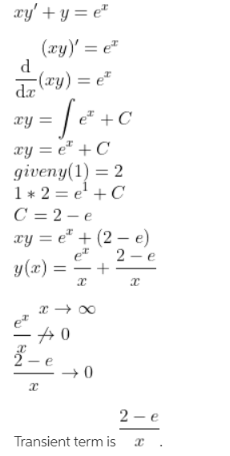
2. Text, letter

   Description automatically generated

Q3. Y = c1 𝑒 𝑥 + c2 𝑒 −𝑥 is a two parameter family of solutions of second order DE y” – y = 0 .Find the solution of the second order IVP consisting of this differential equation and the given initial conditions.

a) Y(1) = 0 , y’(1) = e Ans : y =

𝑒𝑥

2

− 𝑒2−𝑥

2

b) Y(0) =0 , y’(0) =0 Ans : y = 0

1/ Plug the value of y(1) into the given function.

Derivative the function then plug the value of y’(1)

2/ Have 2 functions. Find c1 or c2

3/ Find the another c.

Q4. Solve exact differential equations :

a) ( 5x + 4y ) dx + ( 4x – 8 y3)dy =0 Ans : c = 5𝑥2

2

b) ( 5y- 2x ) y’ -2y = 0 Ans : c = -2xy +

+ 4 xy – 2 y4

5𝑦2

2

c) ( 2 y2 + 3x ) dx+ 2xy dy = 0 Ans : x2 y2 + x3 = c

a.

1/ Check exact

2/ Set eq.1a and 1b

Q5. Solve the given differential equation by appropriate substitution:

a) dy / dx = ( x + 3y ) / ( 3x + y) Ans : (y – x )2 = c( y + x)

b) dy/dx = sin ( x+y) Ans : tan ( x+ y) – sec ( x + y) = x + c

c) dy/ dx = ( 1 – x – y ) / ( x + y) Ans : ( x+ y)2 = 2x + c

Q6.The indicated function y1 ( x ) is a solution of the given differential equation .Use the reduction of order to find the second solution .

a) y “ + 2y’ + y = 0 ; y1 = x 𝑒−𝑥 Ans : y2 = e-x

b) y ’’ + 16 y = 0 ; y1 = cos4x Ans : y2 = sin4x Q7.Find the general solution of the given differential equation:

a) Y(4)-4y’+y=0 , y(1)=0, y’(1)=2 Ans : y = c1ex+c2xex+c3e-x+c4xe-x

b) Y’’ -4y’-5y = 0 ,y(1)=0 ,y’(1)=2 Ans : y=

𝑒1−𝑡

3

+ 𝑒5𝑡−5

3

Q8. Solve by superposition approach y” + y = 4x + 10 Sin x , y ( π ) = 0 , , y ‘ ( π ) = 2 Ans: y = 9 π Cos x + 7 Sin x + 4x – 5x Cos x

Q9. Solve ( using Annihilator approach ) y” – 3y’ = 8 e3x + 4 Sin x

Ans : y = c1 + c2 e3x

+ x e3x

8

3

6 2

+ Cos x -

5 5

Sin x

Q10. Solve ( using Variation of Parameters) y” + y = Sin x

1

Ans : y = c1 Cos x + c2 Sin x -

2

x Cos x

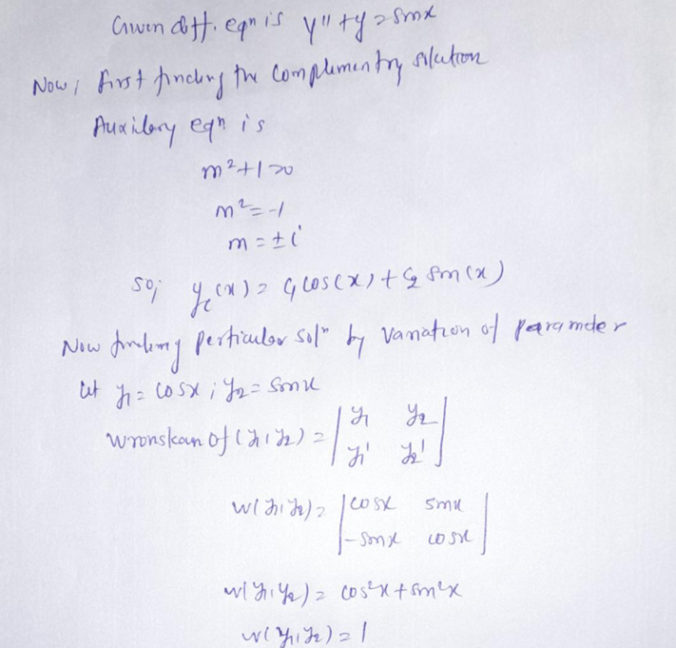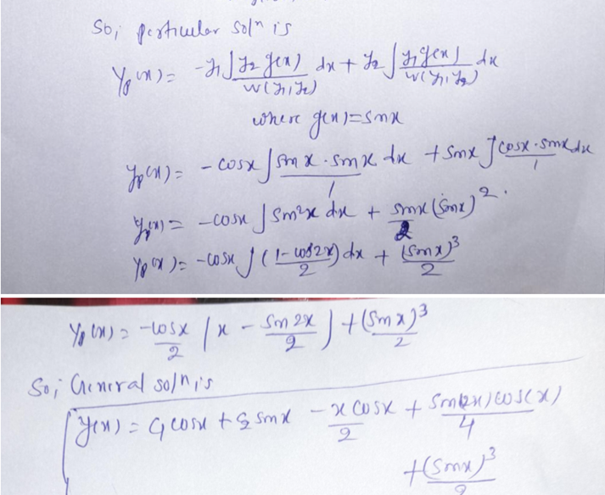

<https://www.chegg.com/homework-help/questions-and-answers/use-laplace-transforms-solve-initial-value-problem-y-y-2-sin-2-t-y-0-10-y-0-0-book-s-answe-q249767>.

Q11 . Solve y’’+y = √2 sin√2t , y(0)=10 , y’(0)=0 Ans: 10cost+2sint-√2𝑠𝑖𝑛√2𝑡

Q12. Find L -1

− 2𝑠+6

𝑠2 +4

Ans : - 2Cos 2t + 3 Sin 2t

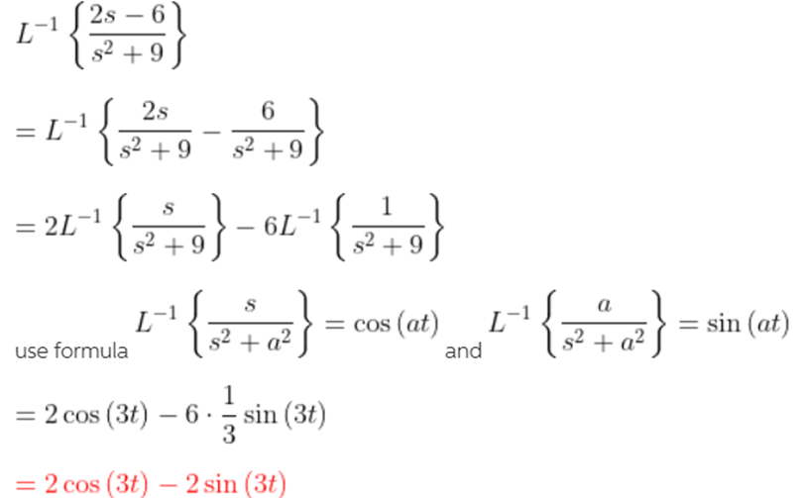

Q13. Evaluate L-1{ 𝑠2+6𝑠+9 } Ans: − 16 𝑒𝑡 + 25 𝑒2𝑡 + 1 𝑒−4𝑡

(𝑠−1)(𝑠−2)(𝑠+4) 5 6 30

Q14.Solve the given differential equation by using Laplace transform:

Y” - 6 y ’ + 13y = 0 y (0) = 0 , y’ (0) = - 3 Ans : (- 3 e3t sin 2t )/ 2

Q15. Solve using Convolution theorem L -1 { 1

2

𝑠(𝑠− 𝑎)

} Ans : ( ateat – eat + 1)/ a2

Q16. Evaluate the inverse transform

L-1 [ 1 ] Ans: et-1

𝑠(𝑠−1)

